Ex.No:4b | EDA– DATA INSPECTION, FILTERING, STATISTICAL ANALYSIS AND CORRELATION

AIM:
To perform data inspection, filtering, grouping, aggregation, descriptive statistical analysis, and correlation analysis using Pandas and visualize the results using Matplotlib.

ALGORITHM:
Step 1: Start.
Step 2: Import the required libraries
Step3: Load the dataset into a pandas DataFrame.
Step 4: Display the first five rows using df.head().
Step 5: Display the shape of the dataset using df.shape.
Step 6: Display the data types of each column using df.dtypes.
Step 7: Filter records based on a condition (e.g., Marks > 85 or Age > 50).
Step 8: Filter records belonging to a specific category (e.g., Department or Disease).
Step 9: Sort the dataset using df.sort_values().
Step 10: Calculate statistical measures:
- Mean
- Median
- Mode
- Standard Deviation
Step 11: Display summary statistics using df.describe().
Step 12 : Group the data using groupby() and calculate the average.
Step 13: Find the correlation between numerical columns using corr().
Step 14: Create a Scatter Plot using Matplotlib.
Step 15: Create a Bar Plot using Matplotlib.
Step 16: Display the graphs.
PROGRAM:
import pandas as pd
import matplotlib.pyplot as plt
print("First 5 Rows")
print(df.head())
print("\nShape")
print(df.shape)
print("\nData Types")
print(df.dtypes)
print("\nPatients with Age > 50")
age_filter = df[df["Age"] > 50]
print(age_filter)
print("\nPatients with Diabetes")
diabetes_patients = df[df["Disease"] == "Diabetes"]
print(diabetes_patients)
print("\nFemale Patients")
female_patients = df[df["Gender"] == "Female"]
print(female_patients)
print("\nSorted by Age")
sorted_df = df.sort_values(by="Age", ascending=False)
print(sorted_df)
print("\nMean Age =", df["Age"].mean())
print("Median Age =", df["Age"].median())
print("\nMode Age")
print(df["Age"].mode())
print("Standard Deviation Age =", df["Age"].std())
print("\nSummary Statistics")
print(df.describe())
print("\nAverage Age by Disease")
disease_avg = df.groupby("Disease")["Age"].mean()
print(disease_avg)
print("\nCorrelation")
corr = df[["Age", "Blood_Sugar"]].corr()
print(corr)
plt.figure(figsize=(6,4))
plt.scatter(df["Age"], df["Blood_Sugar"])
plt.title("Age vs Blood Sugar")
plt.xlabel("Age")
plt.ylabel("Blood Sugar")
plt.grid(True)
plt.show()
disease_avg.plot(kind="bar")
plt.title("Average Age by Disease")
plt.xlabel("Disease")
plt.ylabel("Average Age")
plt.show()

OUTPUT:

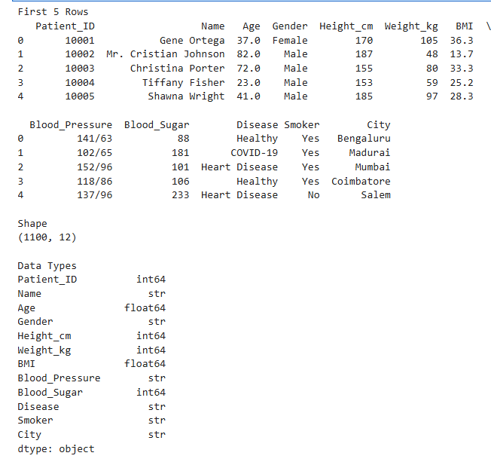
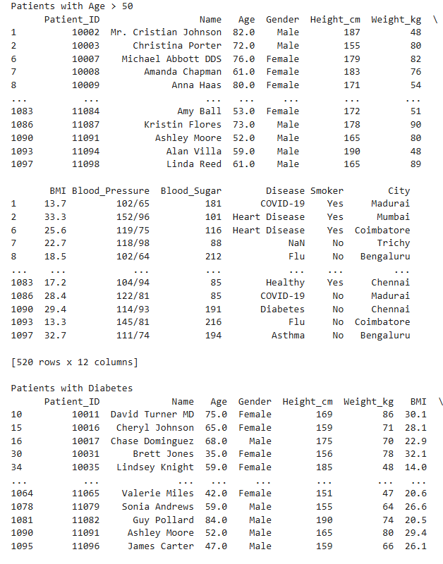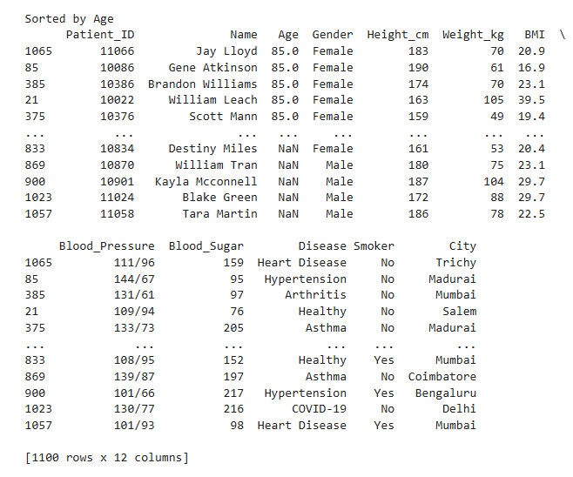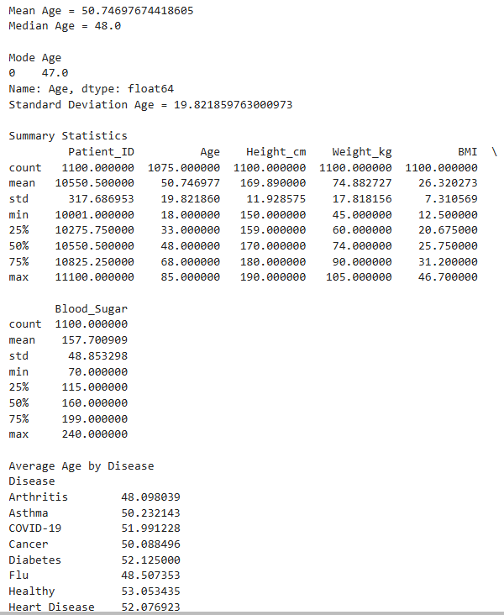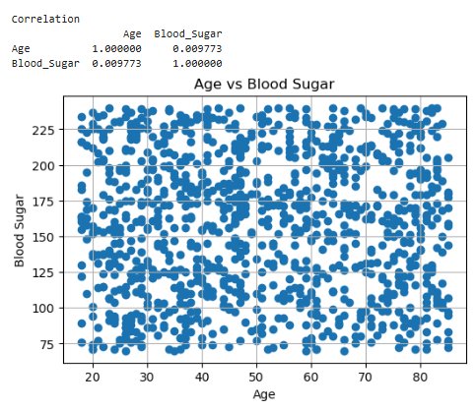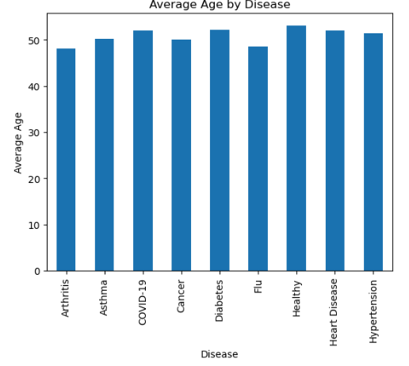

RESULT:
Thus, data inspection, filtering, sorting, descriptive statistical analysis, grouping, aggregation, and correlation analysis were successfully performed using Pandas. The analytical results were visualized and interpreted successfully.

